

TFS-18786; No of Pages 10


Technological Forecasting & Social Change xxx (2016) xxx–xxx
Contents lists available at ScienceDirect

Technological Forecasting & Social Change

A novel approach to forecast promising technology through patent analysis
Gabjo Kim, Jinwoo Bae ⁎
Government Cooperation Team, Korea Intellectual Property Strategy Institute, 131, Teheran-ro, Gangnam-gu, Seoul 06133, Republic of Korea

a r t i c l e i n f o

Article history:
Received 8 December 2015
Received in revised form 28 November 2016
Accepted 29 November 2016 Available online xxxx

Keywords:
Promising technology Patent analysis Technology clusters CPC
Patent indicator
a b s t r a c t

Forecasting promising technology is a relevant opportunity for management of companies and countries. Fur-thermore, researchers in research and development (R&D) have recently considered that patents include de-tailed information on developed technologies. For these reasons, we suggest a novel approach to forecasting PT using patent analysis. The overall process of the proposed methodology consists of three steps. First, to form technology clusters, we clustered patent documents on the basis of the cooperative patent classiﬁcation (CPC), which represents a more detailed technology classiﬁcation system than the international patent classiﬁca-tion (IPC). Second, regarding the process of deﬁning technology clusters, we examined the combination of CPCs of each formed clusters. Finally, patent indicators such as forward citations, triadic patent families, and indepen-dent claims are analyzed to assess whether the technology clusters are promising. We collected patent data on the wellness care industry from the United States Patent and Trademark Ofﬁce (USPTO) to verify the proposed methodology.

© 2016 Elsevier Inc. All rights reserved.

1. Introduction

Promising technology is a key technology that underlies the steady growth of companies and countries. Its inﬂuence on a company's invest-ments and production and on overall national industries is signiﬁcant. Additionally, a promising technology is changing quickly and unexpect-edly. As such, companies and countries that focus rapidly on promising technologies to lead the industry are able to increase their competitive-ness such that it becomes directly connected to survival (Jeong and Yoon, 2015).
Hence, properly forecasting promising technologies is integral for decision makers of both corporations and countries. Upon further ex-amination, ﬁrst, it was found that the establishment of an efﬁcient re-search and development (R&D) strategy establishment is possible. Deriving a comprehensive notion that can satisfy the needs of a future envisioned society as well as the market, forecasting promising technol-ogy is being recognized as an essential stage in the R&D process (Albright, 2002). Speciﬁcally, a national R&D agenda budget can be in-ﬂuenced by the political environment during the R&D planning stage (Halal et al., 1998). This greatly increases the anxiety towards failure re-garding future R&D endeavors. Accordingly, the allocation of an R&D budget should be based on objectivity and validity, as to allow for ade-quately selecting and focusing on a promising technology sector. In other words, by exploring a future environment that humans may face, forecasting promising technology can present a direction on the right path for the early stages of R&D.

⁎ Corresponding author.
E-mail addresses: kkjjo@kista.re.kr (G. Kim), bjw8751@kista.re.kr (J. Bae).
Next, the autonomously led development of products and services becomes possible. As an output of R&D, the developed technology acts as a ﬁrm foundation for the development of future products and ser-vices (Wang et al., 2015). That is, being able to forecast products and services that can lead the future allows for heightened competitiveness compared to rival players.
Accordingly, in the past, such as with the Delphi and scenario methods, attempts have been made to forecast promising technology using expert opinions in related technology areas. However, the prom-ising technology forecasting approach of these expert groups caused problems, including complexity and excessive time required for the procedure, social costs attributable to the mobilization of a large labor force, the absence of credibility for each expert's scope of technology, and different opinions on the interpretation (Choi and Jun, 2014).
As a solution, companies and countries have been establishing future promising technology forecasting strategies using patent analysis (Lee et al., 2009). Patents not only provide legal protection for intellectual property rights, but also include detailed information about the devel-oped technology (Park et al., 2015a). Therefore, forecasting promising technology via patent analysis is signiﬁcant for establishing manage-ment strategies. For instance, it can be used to prevent R&D investments in unnecessary technology areas (Kim et al., 2008), evade loyalty pay-ments required by accidental technology infringements on rival compa-nies (Kim et al., 2015), and design R&D projects to secure core patents (Ju and Sohn, 2015). In other words, from the viewpoint of R&D decision makers, this study can provide signiﬁcant insights to strengthen the fu-ture competitiveness of a company and become an important means for technology management decisions (Ernst, 2013). Therefore, the pur-pose of this study is to forecast future promising technology through

http://dx.doi.org/10.1016/j.techfore.2016.11.023 0040-1625/© 2016 Elsevier Inc. All rights reserved.

patent analysis. In other words, we utilize historical patent data to ob-jectively and quantitatively determine what the promising technologies of the future may be.
We have come to the following conclusions and summarized the fol-lowing contributions through our study on the methodology of fore-casting promising technology.

- We are able to identify the speciﬁc detailed technological areas that compose different technologies and industries. For this, we utilize the systematic and accurate properties of the patent classiﬁcation system, as included in the patent information. These technological areas may be convergence, existing, or even technologies that can create disruptive innovation.
- We are able to determine and verify the evidence of promising pros-pects in existing technological ﬁelds. Based on the application year of the collected patent data, we postulate the training set from 2002 to 2009, and the test set from 2010 to 2013. In doing so, we test the re-stricted model by examining how much of an inﬂuence the current promising aspect valuation of technologies have had on the future. Here, we evaluate technology valuations using patent information.
This study is not based on technology forecasts made using the sub-jective judgments of experts, but upon patent data analysis, which con-tains detailed information about the technology used. Therefore, even those without technological expertise can produce objective promising technology forecasts. By identifying the opportunity creation of new technologies, we hope to utilize this as a tool to forecast the promising technologies that can substitute current ones.
This paper is organized as follows. Section 2 reviews the case studies on patent analysis and technology forecasting. Section 3 reveals the pro-posed methodology for the actual forecasting promising technology analysis. Section 4 presents the experimental results, while Section 5 provides the conclusions and implications of the study.

- Literature review

  - Patent analysis

A patent is an accessible document that contains information on both the developed technology and its usage rights (Park et al., 2005). Such patents grant exclusive rights in exchange for disclosing the tech-nology (Trappey et al., 2011). Therefore, in the case of important soft-ware or algorithms, where it is difﬁcult to determine if a competitor has infringed on patents, companies often own these technologies as know-how instead of applying for patents. Furthermore, in some coun-tries, which had inadequate systems for protecting intellectual property rights in the past, companies intentionally did not apply for patents, as their intellectual property rights were not properly protected compared to the high costs and time required for application.
However, presently, countries and companies are increasingly changing their perception and patenting their technologies (Manap et al., 2016) when such technologies include clear technological concepts and reverse engineering is possible. Accordingly, with the growing em-phasis on the importance of intellectual property rights that assure ex-clusive rights over a developed technology, there is an increase in recent efforts to obtain patents (Park et al., 2015b). Furthermore, there is an emergence of non-practicing entities (NPEs) that acquire high quality patents with wide scope (Fischer and Henkel, 2012) to legally challenge the companies that practice patent infringement or make a proﬁt by reselling the patents to other companies (Pénin, 2012). It im-plies that a patent can contribute signiﬁcantly towards proﬁt creation if it is utilized for offensive or defensive purposes by an organization.
Patents are also used to develop technologies that are more ad-vanced than the existing versions around these patents (Belvard, 2000). That is, they not only have offensive and defensive functions but can also be used as an efﬁcient technology management strategy.
Especially at a national level, they can be used to establish public pol-icy. For instance, research has been conducted on the direction of future policy for detailed technologies, based on pinpointing leading patent applicants and countries for electrochemical energy storage technology (Mueller et al., 2015). Additionally, research of the time range of patents in the solar thermal utilization sector, technology type distribution, and technology trend analysis had been used to establish governmental en-ergy policies (Zhao and Zhao, 2015). There has been research on patent analysis of global wind turbine companies, which provided a direction for policies for discovering new markets in Asian and European nations and for company policies about encouraging open innovation among companies (Zhou et al., 2015).
From the perspective of technology management planning, identify-ing the effective technology development trends of rival competitors and reviewing whether or not to introduce new technology can be done through patent analysis. Identifying the technology life cycles of patents in telematics revealed the possibility for new technology crea-tion by connecting mobile devices to cloud platforms (Chang and Fan, 2016). The R&D tendencies and trends in the target sectors for leading companies in the ﬁeld of amorphous silicon are examined (Tseng et al., 2011). By dividing companies into those with leading technology, those with technological potential, and those with technology quality orientation, based on calculated patent indicators, detailed competitive-ness of these companies can be identiﬁed. Furthermore, researchers without detailed knowledge of technology can easily determine techno-logical trends and important technologies through patent analysis (Chang et al., 2012). In other words, the study understood the relation-ships between patents and discovered key patents by forming a patent network based on similar terms that were used in different patents.
Therefore, this study approaches patents, which have become im-portant for countries and corporations, from the establishing policies and technology management perspective because earlier studies have drawn technological implications from patent analysis.

  - Forecasting promising technology

Forecasting promising technology plays an important role in deci-sion making for enterprises' and countries' management of technology. In the past, qualitative analysis, such as the Delphi and scenario ap-proach methods, was based on technology forecasts.
In the Delphi analysis approach, the consensus process among ex-perts heightens objectivity and persuasiveness. For example, Delphi analysis has been conducted to predict the future technologies in the public relations sector. Technology experts from various ﬁelds and from all over the world participated and reviewed dozens of topics that had previously been overlooked or ignored (Kent and Saffer, 2014). Experts were divided into groups to carry out Round 3 of the Del-phi study, as to identify the determinants of business opportunities in the emergent bioenergy industry at both company and industry level (Pätäri, 2010). Therefore, Delphi analysis can be valuable when past data is unavailable or in cases where mathematical modeling is impossible.
The scenario analysis approach is useful as a base for establishing a strategy for a variety of uncertain factors. Such scenario analysis postu-lates and generalizes how various possible uncertain situations may evolve. Having ﬁlled out the technological road map, scenario planning is a prerequisite for making precise predictions possible (Saritas and Aylen, 2010). Using the current technological situations, market needs, evaluation and understanding of products and services, and technolog-ical inﬂuence analysis, a scenario analysis to satisfy the market needs considering future uncertainties was conducted (Holmes and Ferrill, 2005).
Moreover, a combination of the Delphi and scenario analyses can provide accurate predictions as well. The probability of occurrence for certain future events can be estimated in Round 3of the Delphi analysis,

based on the scenario analysis for predicting mobile broadband trafﬁc (Lee et al., 2016).
However, these qualitative analyses have drawbacks. First, the Del-phi draws its conclusions by exchange and development of expert opin-ions in the relevant area. Because the method relies entirely on subjective judgments, experts' biased judgments of a technology fore-cast are a disadvantage. The instances are experts' tendency to keep their existing R&D areas, personal or organizational inclinations, halo ef-fect that relies on well-known researchers or institutions, and different criteria for selecting promising technology. Furthermore, it is very difﬁ-cult to ﬁnd willing participants for this method (Kent and Saffer, 2014). The scenario method also has reliability limitations because it is based on limited future aspects with a high possibility of occurrence. Addition-ally, the composition of the scenario can be arbitrary (Amer et al., 2013). As a result, although qualitative technology forecasts will continue to exist, it should be accompanied by data-based quantitative analysis (Bengisu and Nekhili, 2006).
To overcome these limitations, numerous studies on future promis-ing technology forecasts analyzed patents with detailed information on the patented technologies. This is because patents provide sufﬁcient data for drawing reliable conclusions in studies examining technological change and innovation (Chang et al., 2012).
For instance, research is being conducted to forecast future technol-ogy using a growth curve based on the number of patent applications. The logistic growth curve is applied to nano-sized ceramic powder tech-nology patents (Cheng and Chen, 2008) and to building integrated pho-tovoltaic technology patents (Chiu and Ying, 2012), respectively. The logistic growth curve and the Bass model are then applied to patents on information and communications technology (ICT) applications (Meade and Islam, 2015). Furthermore, the growth curve of forward ci-tations for TFT and LCD, ﬂash memory systems, and personal digital as-sistants is applied as a criterion to forecast future technology (Altuntas et al., 2015). As such, these studies forecasted promising technology by commonly examining future demand and the diffusion of patents.
There are also studies that provide technology forecasts by applying various data-mining approaches to patents. Promising technology is identiﬁed using association rule mining of international patent classiﬁ-cations (IPCs) for patent documents (Jun et al., 2012a). Additionally, the promising aspects of technology are determined by applying associ-ation rule mining to changes in patent indicator values over time for each IPC (Shih et al., 2010). Moreover, applying network analysis to IPCs, the relationships between technologies are visually expressed and whether the technology is promising based on the centrality be-tween IPCs and the distance between nodes is determined (Park et al., 2015c).
Studies on forecasting future promising technology by applying a text mining technique to an unstructured patent title and abstract have been conducted as well. Text mining for Apple Inc. patents is ap-plied for identifying the promising vacant technologies (Jun and Park, 2013). Additionally, a study was conducted to forecast vacant technolo-gies by applying the generative probabilistic model of latent Dirichlet al-location to renewable energy technology patents (Kim et al., 2015). Another study examined vacant technology areas and its promising as-pects by obtaining patent keywords and then applying generative topo-graphic mapping as a probabilistic reformation of a self-organization map (Jeong et al., 2015).
These research experiments are signiﬁcant in objectively deriving data-based promising technology. However, some limitations do exist. Reliability is absent, given that the growth curve from the accumulated number of patents does not take into account a variety of environmental factors on the relationship among complex technologies. Additionally, researchers' qualitative judgments are still included in patent analysis on the basis of the keyword-based approach (No et al., 2015a). More-over, because the IPCs of patents rely signiﬁcantly on broad and abstract technology classiﬁcations, it is difﬁcult to understand and interpret technologies in great detail.
Although limitations exist, various approaches have been attempted in studies for promising technology forecasts and insightful messages identiﬁed, such as technology areas in which researchers commonly need to be actively committed to R&D. Therefore, this study forecasts fu-ture promising technology through new approaches to patent analysis to overcome the existing drawbacks of promising technology forecasts and allow researchers to engage new markets and strengthen technolo-gy competitiveness.

- Methodology

The purpose of this study is to forecast promising technology by an-alyzing wellness care industry patent data in the United States. To do so, as mentioned in Section 3, wellness care patent data were collected from the United States Patent and Trademark Ofﬁce (USPTO) (The United States Patent and Trademark Ofﬁce (USPTO), 2015), and data mining and patent indicator analysis on a variety of bibliographic infor-mation from the collected patent documents were performed. Fig. 1 in-dicates the overall process of the proposed methods for forecasting promising technology (Fig. 1).

  - Selection of technology ﬁeld

The interest in wellness care—the optimal health condition for the physical, mental, and social state—has received signiﬁcant interest. In particular, around 52% of adults older than 50 receive complementary
health care in the United States (Johnson et al., 2016) and its vast invest-ment in health care shows great potential for growth in the wellness in-dustry (Fujii et al., 2016).
This development in the wellness care industry is expanding from the convergence of IT and various industries. In particular, the activation of the wellness care industry integrated with IT and medicine likely makes it a suitable industry for forecasting promising technology (Kim, 2015). Thus, in this study, we adopted the wellness care industry to experimentally verify the new patent analysis approach for promis-ing technology forecasts.

  - Data acquisition

The United States is a marketplace with the largest demand for tech-nology and has the fastest technology development in the wellness care industry (Anon, 2010). Accordingly, the world's leading companies con-tinuously publish patent applications to the USPTO to obtain protection for rights on new technologies that they develop. In this study, we fore-casted promising technology by analyzing patent data from the USPTO on the wellness care ﬁeld.

  - Technology clustering

To effectively search and manage a signiﬁcant amount of patent in-formation, a patent classiﬁcation system that complies with the current state of technology and user needs is necessary. Such a patent classiﬁca-tion system is utilized in a prior art search as introduced through various nations' classiﬁcation systems, such as IPC, ﬁle index (FI), and CPC.
Subdividing technology system countries with large numbers of pat-ent applications, including the United States, European countries, and South Korea, is done through a CPC system that is ﬂexible and that can be quickly revised (Mueller et al., 2015). The CPC has more than 250,000 entries, which is larger than FI with approximately 180,000 en-tries and IPC with approximately 70,000 entries (Kapoor et al., 2015). Therefore, in this study, we cluster patent documents for a similar tech-nology using the CPC information in each document.
A patent document has more than one CPC and can be composed of a patent-CPC matrix (PCM), which is an asymmetrical matrix as shown in Fig. 2 (a). We then constructed a patent-patent matrix (PPM) as a

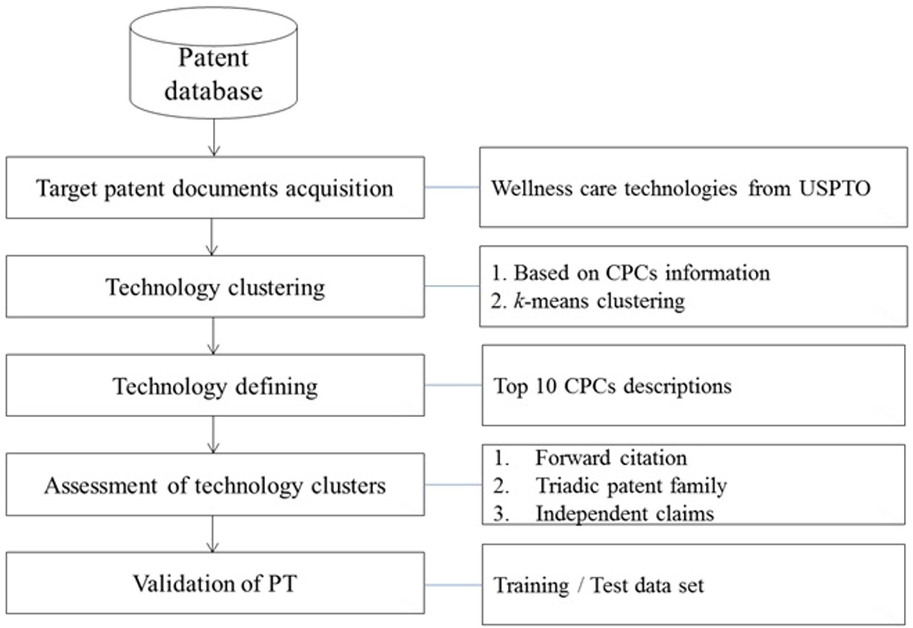

Fig. 1. Overall process of the proposed methodology.
2

symmetrical matrix, as shown in Fig. 2 (b). To construct the PPM, we
where V₂ indicates eigenvectors e₁ and e₂, and Λ^{1/2} indicates square root

calculated the Pearson's correlation coefﬁcient between patent documents.
Patent documents can be mapped on a low dimensional space through multidimensional scaling (MDS). MDS is a multivariate statisti-cal method to visually reduce data from a high dimensional space to a low dimensional space (Cox and Cox, 2001). To perform MDS, n data need to form a (dis)similarity matrix. In this study, the data are repre-sented by a dissimilarity matrix with the range value of [0,2] by taking
1–coefﬁcient. Next, double centering is applied as follows:

B ¼ − 1 HD^{ð2Þ}H ð1Þ
2

where D⁽²⁾ is the matrix of squared proximities and is applied to the previous matrix of squared proximities. H ¼ I− 1 ee^{T}, where I is an iden-tity matrix with n observations. Next, in this study, following Eq. (2), the eigenvector decomposition of B is indicated to project patent docu-ments onto the two dimensional space.
n
values of λ₁ and λ₂.
Next, we clustered patent documents with a similar technology on a two-dimensional space by adopting k-means clustering. k-means clus-tering is a partitioning clustering method through which the principal objective is to divide the given data into a number of k clusters with sim-ilar aspects (Hartigan and Wong, 1979).
The following brieﬂy explains the principle of k-means clustering. First, given k seed points, the initial cluster's centroid is randomly set. Second, the set of data is assigned to the cluster that has the nearest cluster centroid. Third, the centroid of each cluster is readjusted by reassigning the average of the observations in the cluster. The repetition halts if changes no longer occur in the clusters.
To conduct the k-means clustering, the distance metrics and the number of clusters k should be selected in advance. Several methods may be used to evaluate the distance metrics, such as Euclidian distance, Manhattan distance, Chebyshev distance, and Spearman distance. In this study, we clustered the patent documents with k-means clustering using Euclidian distance.
In addition, to determine the optimal number of clusters, k, we con-

Y ¼ V Λ ¹⁼²
ð2Þ
sidered the average silhouette width concept (Rousseeuw, 1987). The

2 2 silhouette width is used to evaluate the validity of the clustering results,
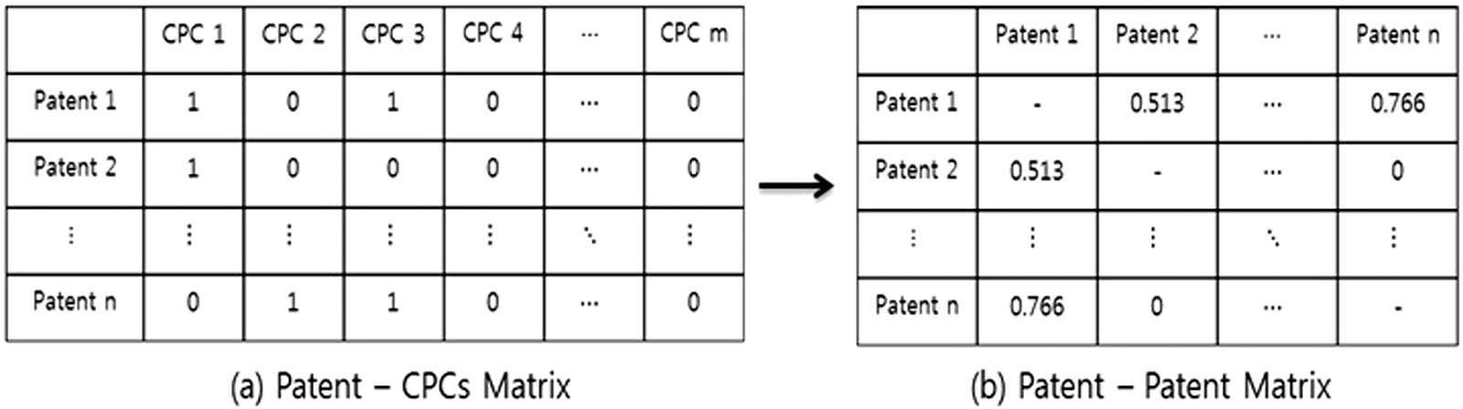

Fig. 2. Transforming PCM into PPM.

which can be used to determine the optimal number of clusters. The sil-houette width of the ith observation is computed as follows:
auction prices as economic value (Fischer and Leidnger, 2014). The older and more important a patent is, the more frequently the patent tends to be cited by other patents (Yoon and Kim, 2012). We do not con-

sw b_{i}−a_{i}
_{i} ¼
maxfb_{i}−a_{i}g
ð3Þ
sider the time lag of such forward citations but rather values such as the technological inﬂuence of the patents.
In this study, the forward cites per patent about an i technology clus-

where a_{i} denotes an average dissimilarity between the ith observation and the other observations within the same cluster and b_{i} represents
an average dissimilarity between the ith observation and the other ob-
ter is calculated as follows:
forward cites per patent ¼ FCi

ð4Þ

servations belonging to a neighboring cluster. sw_{i} has a value ranging from −1 to 1, and a value closer to 1 implies better-composed cluster-ing. Therefore, the value of sw_{i} is the ith observation's silhouette width and the optimal number of clusters corresponds to the widest average silhouette width.

  - Technology deﬁning

A number of previous studies used text mining or IPC on the process of deﬁning technology after formation of technology clusters. However, the deﬁnition of technology cluster through text mining has the disad-vantage of extreme subjectivity and the distribution of signiﬁcant noise. This is because different researchers may produce different re-sults if the technology clusters are deﬁned based on the top ten (Choi and Jun, 2014) or ﬁve (Jun et al., 2012b) terms without expertise in each technology area.
On the contrary, as was previously mentioned, CPC classiﬁes tech-nologies in greater detail than does IPC. Thus, this study deﬁnes technol-ogy clusters based on the ten CPCs that most frequently appear in each technology cluster because this method can establish more objective deﬁnitions of technologies compared to existing technology deﬁnition methods based on terms and IPCs. There may be overlapping CPCs in the formed technology clusters since various technological factors can be amalgamated. Therefore, by also accounting for the CPC composition ratios of the formed technology clusters, we show whether the overlap-ping technology clusters are completely identical or are amalgamations of similar technological factors.

  - Assessment of technology clusters

After the formed technology clusters are deﬁned, we calculate the patent indicators to judge the promise of the clusters. Patent citation was used as an important indicator of the technology forecast (Chang et al., 2009; Fallah et al., 2009). Additionally, patents that are entered in major markets such as the United States, Japan, and Europe—called
the triadic patent family—suggest qualitatively important technologies.
i Ti

where FC_{i} indicates the total number of forward citations of technology cluster i and T_{i} indicates the total number of patents of technology clus-ter i.

    - Triadic patent family
The triadic patent family indicates patents for which the same inven-tion, same inventor, or applicant applied to USPTO, JPO, and EPO at same time. In 1999, the OECD used this concept to evaluate national technol-ogy competitiveness (Lee and Sohn, 2013).
Triadic patent family is now used as an important indicator when evaluating the technology level of countries or companies because the United States, Japan, and Europe are regarded as major markets (Baudery and Dumont, 2006). The right of an inventor to the invention increases through patent applications ﬁled abroad. However, such ap-plications take signiﬁcant time and costs. Therefore, technologies with many applications in major markets have high values and strong inter-national competitiveness. In this study, triadic patent family is calculat-ed as follows:
triadic patent family ¼ TPi ð5Þ
i Ti

where TP_{i} represents the total number of patents in technology cluster i applied simultaneously to USPTO, EPO, and JPO, and T_{i} represents the total number of patents of technology cluster i.

    - Independent claims
In a patent, the essential information for the conﬁguration of the in-vention is written in independent claims and may be used as an indica-tor of the amount intellectual property rights (Petruzzelli et al., 2015). In other words, because the number of independent claims is proportional to the number of inventions, a large number of independent claims per patent may be viewed as a technology with robust rights (Lee and Lee, 2010). The independent claims per patent can be calculated as follows:

Moreover, the number of independent claims can be indicated as the
independent claims per patent ¼ ICi
ð3Þ

number of inventions. This is because each patent claim denotes the legal deﬁnition of the invention (Trappey et al., 2012). Thus, the number of independent claims is proportionate to the number of technologies possessed by the patent holder. In this study, as an indicator to deter-mine promising technology, the following three pieces of patent infor-mation are considered: (i) forward citation, (ii) triadic patent, and (iii) independent claim. These indicators are explained in the following subsection.

    - Forward citation
Forward citation in a patent states prior art documents as bibliogra-phies. These documents are determined to be technologically closely re-lated to the invention. That is, the fact that one patent is cited in many different patents indicates that it creates technological and economic value through important contributions to future technology develop-ment. Furthermore, one can understand knowledge ﬂows from the in-formation in forward and backward citations (No et al., 2015b).
The forward citation of patents has been widely applied as an impor-tant indicator to evaluate the value of technology (Lee et al., 2012). Ad-ditionally, the citation is signiﬁcantly correlated with real-world patent
i Ti

where IC_{i} represents the total number of independent claims in technol-ogy cluster i and T_{i} indicates the total number of patents of technology cluster i.

- Experimental results

We collected patent data on wellness care from 2002 to 2014 for ex-perimental veriﬁcation of the recommended methodology. However, as shown in Fig. 3, one section is not totally disclosed because all applied patents have not yet been published from 2013 to 2015 because it takes around one and a half years to disclose every issued patent. There-fore, we excluded patent data after 2013, since it is only partially disclosed.
For experimental validation, we classiﬁed patent data from 2002 to 2009 into a training set and from 2010 to 2013 into a test set. This is to empirically test whether the promising technology derived from the training set led to a large number of patents in the test set. From the entire set of 2182 patent documents collected, the training set

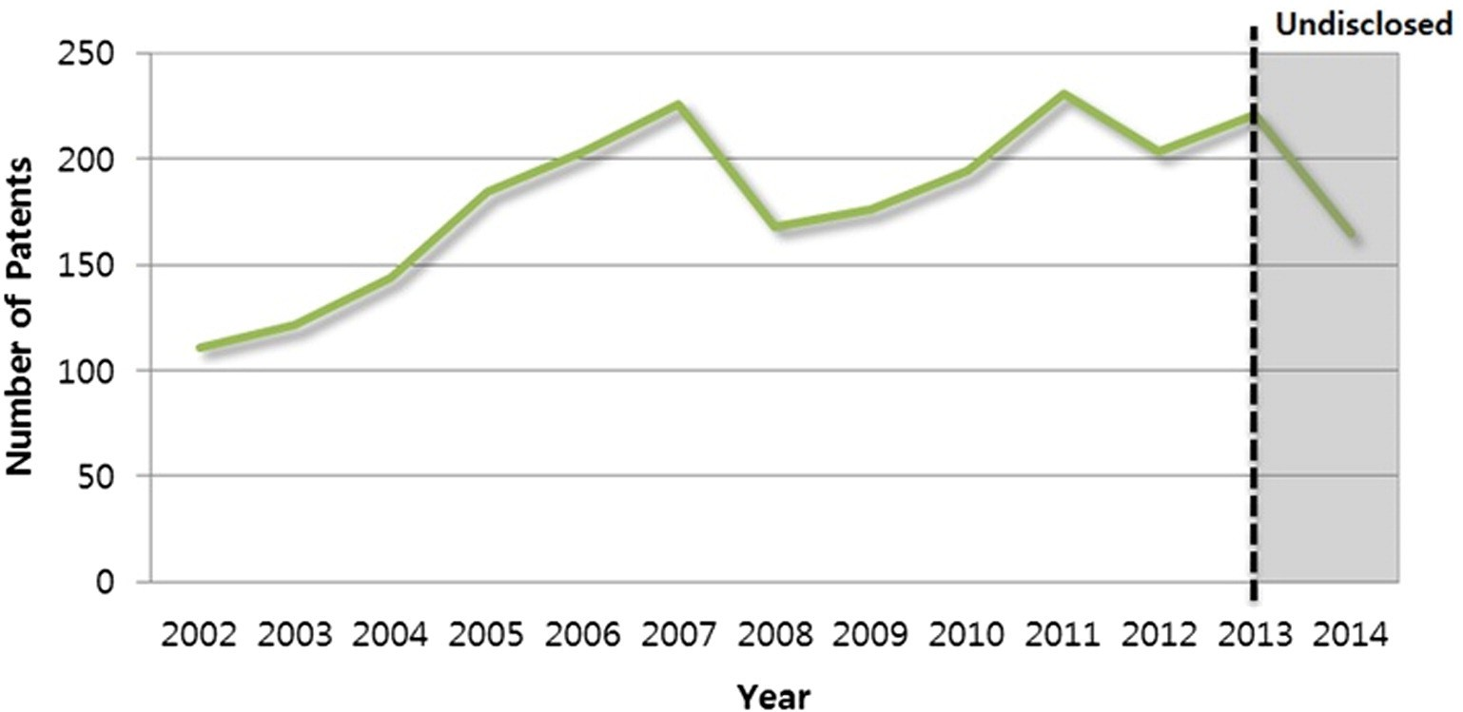

Fig. 3. Number of wellness care patents in the United States by year.

includes 1333 patent documents and the test set includes 849 patent documents. First, CPCs within patents are parsed to cluster patent doc-uments with similar technology. The CPCs on wellness care from the collected patent data from the USPTO are distributed as indicated in Fig. 4.
After examining the results of the types of CPCs held by each pat-ent, 1333 × 1442 PCM were formed as 1442 CPCs and a total of 1333 patents in the case of the training set and 849 × 1326 PCM were formed as 1326 CPCs and 849 patents in the case of the test set. To present each PCM as a form of a dissimilarities matrix, we calculated a value by subtracting 1 from the value of the Pearson's correlation coefﬁcient between patent documents. The range of the matrix vector values for the training set and the test set is [0, 1.032576] and [0, 1.037801], respectively. Ranges closer to 0 indicate a dissim-ilarity matrix, which becomes a similar relationship. For visualiza-tion, patent documents are projected to a two-dimensional space through MDS, as shown in Fig. 6.
Next, to cluster patent documents mapped in two-dimensional space, the optimal cluster number k should be determined. When the number of clusters k of both the training set and the test set is 3, the av-erage silhouette width value is the highest, at 0.69, as shown in Fig. 5.
Therefore, the optimal number of clusters k from these two sets is deter-mined to be 3. The result of performing k-means clustering after the value of k is determined is shown in Fig. 6. In the training set, cluster 1 has 483 (32.9%) of the 1333 total patent documents and cluster 2 and
cluster 3 have 653 (49.0%) and 42 (18.3%) documents, respectively. Cluster 1 of the test set has 137 (16.1%) of the 849 patent documents and cluster 2 and cluster 3 of the test set has 253 (29.8%) and 459
(54.1%) documents, respectively.
We examined the top 10 CPCs included in each technology cluster to deﬁne the formed technology clusters as shown in Table 1. The Appendix A shows the descriptions corresponding to each CPC.
As a result, cluster 1 of the training set is matched to cluster 2 of the test set as a technology related to an entire wellness care business sys-tem, such as health care and patient management. Additionally, cluster 2 of the training set is matched to cluster 3 of the test set as a telemed-icine technology providing clinical health care services using telecom-munications and information technology at a distance. Cluster 3 of the training set is matched to cluster 1 of the test set as a data management technology, such as for patient records and medical imaging data. As a result, three of the same technology clusters from the training set and the test set are formed.

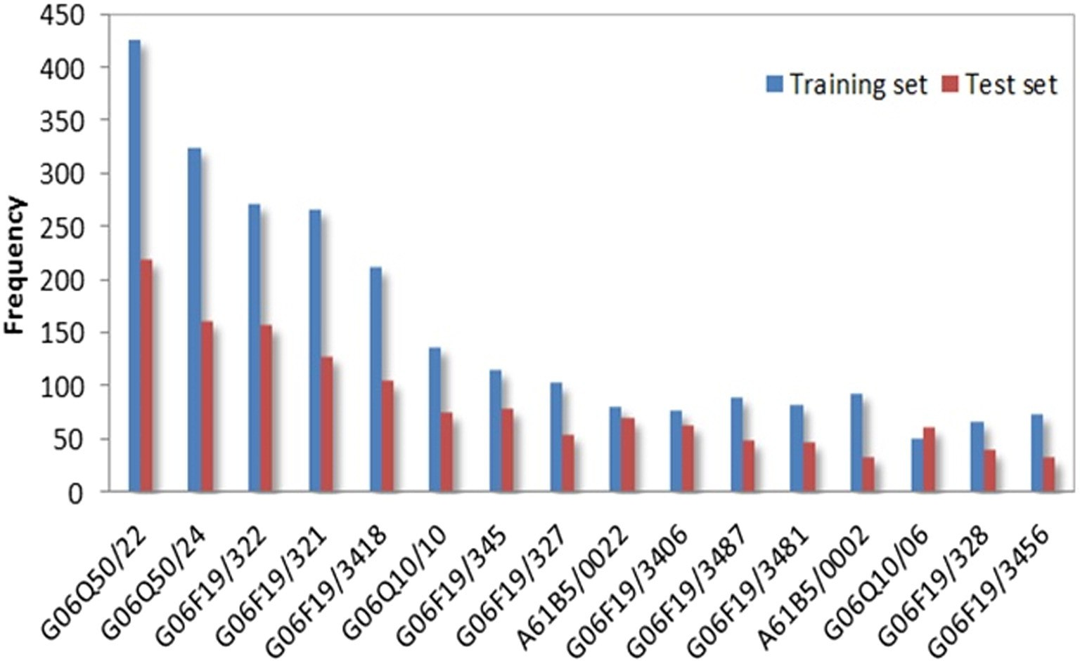

Fig. 4. CPC frequency for training and test sets on the wellness care ﬁeld.

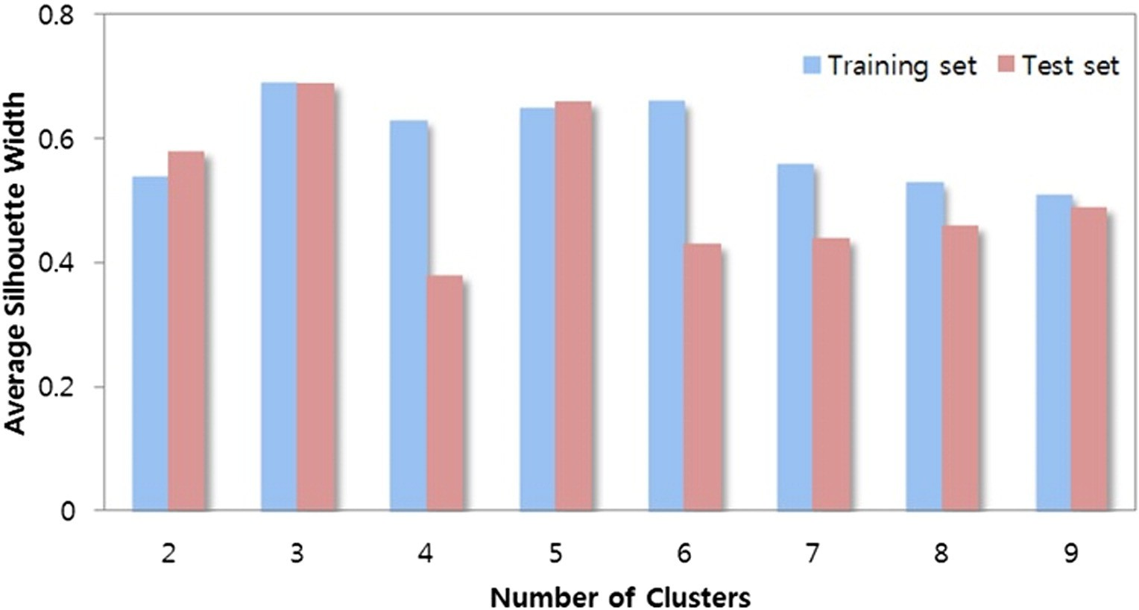

Fig. 5. Results of the average silhouette width of the training and test sets.

Here, we examined the common CPCs that appear in each formed technology cluster. There are 7 CPCs commonly contained in two technology clusters in the training set. In particular, there are more than 5 overlapping CPCs cluster 1 (wellness care business system technology) and cluster 3 (data management technology). This im-plies that the technology compositions of cluster 1 and cluster 3 are analogous. However, these cannot be viewed as perfectly identi-cal technologies because, as Fig. 7 shows, the CPC composition ratios of these technology clusters are considerably different. This implies that data management technology has some mutually complemen-tary components and exclusive relationships with data management technology (Anon, 2015). In other words, there have been integra-tions of similar technologies. This is also the case for cluster 1 and cluster 2 in the test set.
After the technological deﬁnition of a formed technology cluster, patent indicator analysis was performed to determine the promise of each technology cluster. As Table 2 shows, the promise for cluster 2 as determined by comparing forward citation per patent, triadic patent family, and independent claims per patent of the promising technology cluster candidates was 0.62787, 0.54242, and 4.03216, respectively. This
cluster was concluded as being a promising technology cluster with the highest values among the three clusters.
Cluster 2 of the training set is the same as cluster 3 of the test set, and its portion was signiﬁcantly increased from 49.0% to 54.1%. Additionally, the value of the patent indicators of cluster 1 and cluster 3 were signiﬁ-cantly lower than that of cluster 2. Moreover, from cluster 1 and cluster 2 of the test set, these portions were decreased from 18.2% to 16.1% and 32.9% to 29.8%, respectively. This shows that, since data management and wellness care business system technology are less promising than telemedicine, R&D for the former two has been slow regarding the test set period from 2010 to 2013, while R&D for telemedicine has been active in the test set period due to its promising past achievement. Therefore, our proposed methodology accurately forecasted promising technology.
This result shows that forward citations, family patents, and the bib-liographic information of independent claims can be used as indicators to evaluate the prospects of a technology. In addition, as mentioned ear-lier, because data management technology and business system tech-nology have less clear technological concepts, as do algorithms and software, than telemedicine technology, that there has been relatively less vigorous patent activities in these areas.

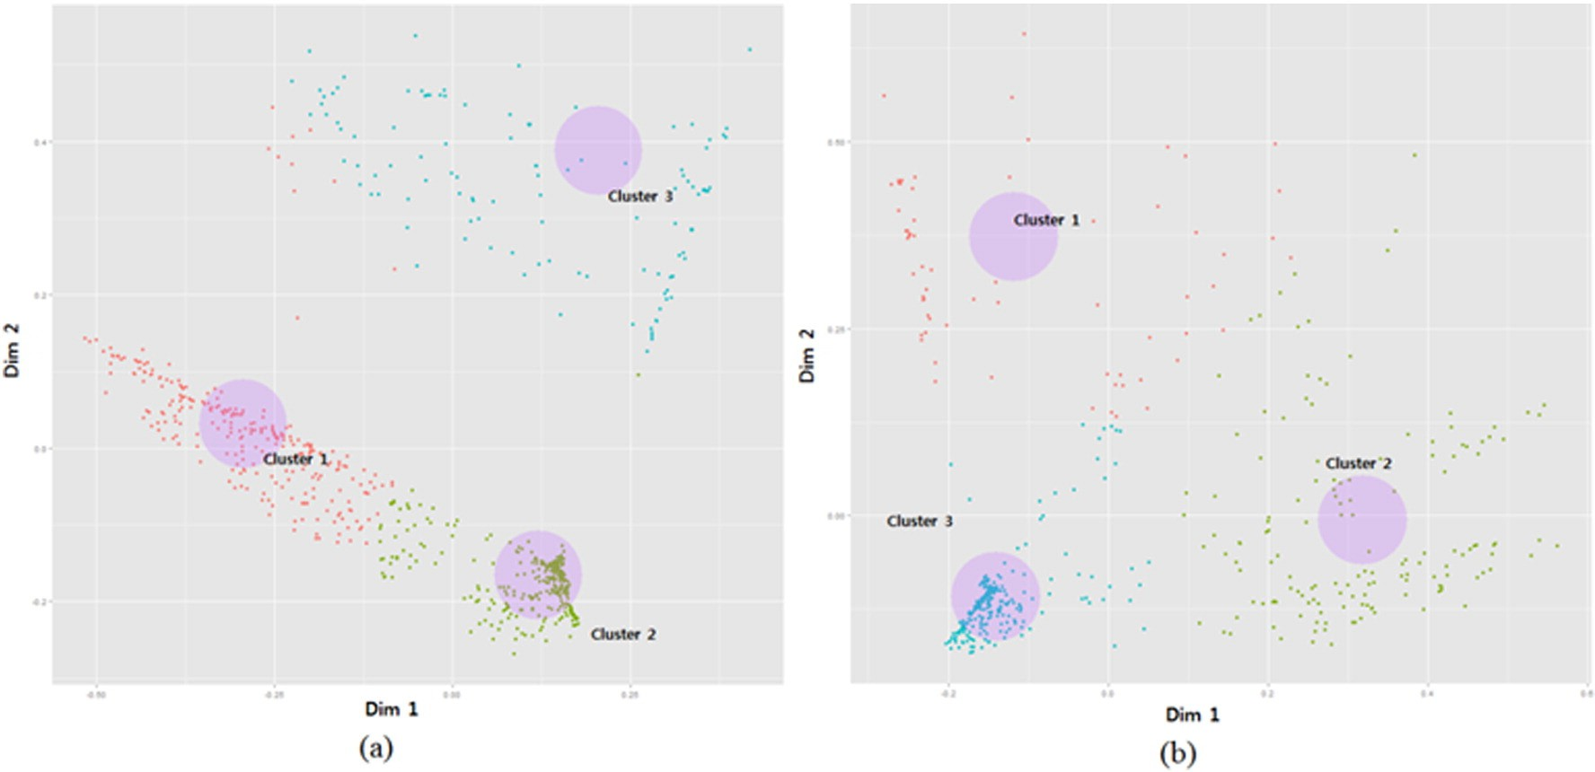

Fig. 6. Graphical results of patent projecting and clustering on the two-dimensional space of training set (a) and test set (b).

Table 1
The result of CPCs for each technology cluster of training and test sets.

Rank | Training set |  |  |  | Test set
 | Cluster 1 | Cluster 2 | Cluster 3 |  | Cluster 1 | Cluster 2 | Cluster 3
1 | g06q50/22 | g06f19/3418 | g06f19/321 |  | g06f19/321 | g06q50/22 | a61b5/0022
 | (359)ª | (85) | (242) |  | (216) | (206) | (60)
2 | g06q50/24 | a61b5/0002 | g06q50/22 |  | g06f19/322 | g06q50/24 | g06f19/3418
 | (265) | (74) | (59) |  | (65) | (148) | (55)
3 | g06f19/322 | a61b5/0022 | g06q50/24 |  | g06q50/24 | g06f19/322 | g06f19/345
 | (205) | (45) | (47) |  | (29) | (82) | (40)
4 | g06f19/3418 | g06f19/322 | g06f19/322 |  | g06q50/22 | g06q10/10 | g06f19/3406
 | (117) | (37) | (30) |  | (23) | (60) | (39)
5 | g06q10/10 | g06f19/345 | g06q10/10 |  | g06f19/3487 | g06q10/06 | a61b5/1118
 | (111) | (34) | (17) |  | (15) | (55) | (32)
6 | g06f19/327 | g06f19/3481 | g06f19/3487 |  | g06q10/10 | g06f19/3418 | a61b5/0205
 | (84) | (34) | (15) |  | (14) | (41) | (30)
7 | g06f19/345 | a61b5/14532 | g06f17/30265 |  | g06f19/327 | g06f19/327 | a61b5/02055
 | (78) | (33) | (13) |  | (13) | (39) | (29)
8 | g06f19/3487 | a61b5/0006 | g06f19/3418 |  | g06f19/3418 | g06f19/328 | a61b5/0002
 | (64) | (31) | (10) |  | (12) | (32) | (28)
9 | g06f19/345106 | a61b5/0205 | g06 t7/0012 |  | g06 t7/0012 | g06f19/3487 | g06f19/322
 | (60) | (30) | (10) |  | (10) | (30) | (24)
10 | g06f19/328 | a61b5/024 | y10s707/99945 |  | g06f19/323 | g06f19/345 | g06f19/3481
 | (57) | (30) | (9) |  | (9) | (29) | (24)
ª ( ) indicates the number of CPCs.

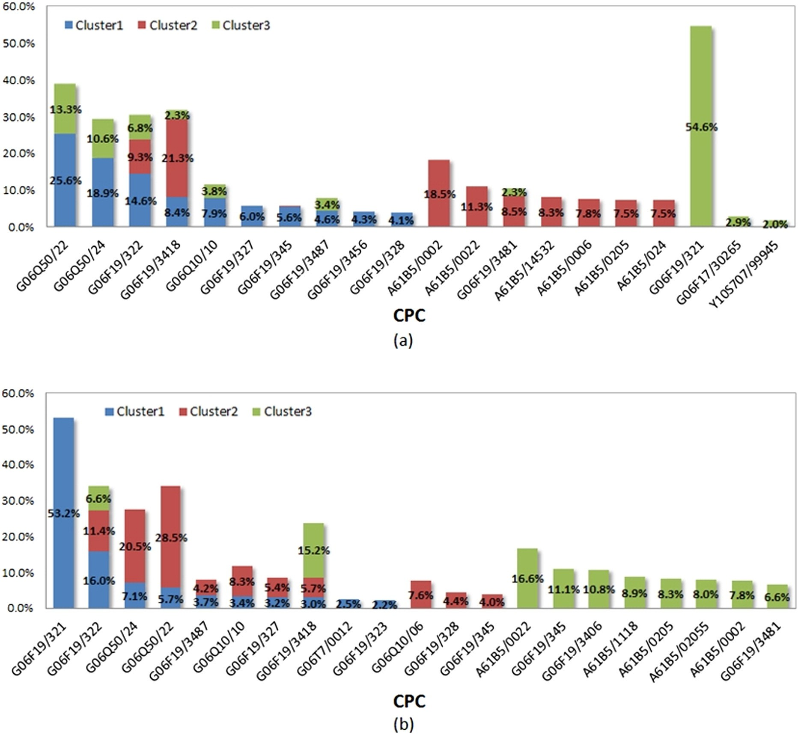

Fig. 7. CPC distribution for each formed technology cluster in the training set (a) and test set (b).

Table 2
Patent indicator analysis results for the training set.

 | Forward citations per patent | Triadic patent family | Independent claims per patent
Cluster 1 | 0.52055 | 0.32727 | 3.83333
Cluster 2 | 0.62787 | 0.54242 | 4.03216
Cluster 3 | 0.58264 | 0.13030 | 3.70661

- Conclusion

In this paper, we forecasted the promising technology of the well-ness care ﬁeld using patent information from the USPTO. First, to form technology clusters with similar technologies, we considered CPCs be-cause they include much more detailed information on technologies than do IPCs. Next, to understand the promise of each formed technolo-gy cluster, we use the patent information to calculate patent indicators, including patent family, forward citations, and independent claims. The reason is that such indicators are important pieces of information used mainly to assess the value and level of technology.
From the total data set collected for the experimental validation of the methodology, we classiﬁed the periods from 2002 to 2009 as the training set and from 2010 to 2013 as the test set. This is because it is possible to objectively conﬁrm whether the promising technology re-sults drawn from the promising technology forecasting model used for the ﬁrst period were in fact patented in the actual future period.
Consequently, we selected telemedicine technology, which has rela-tively higher indicator values, as a candidate promising technology cluster of the training set. Furthermore, the portion of telemedicine technology in
technology through the same method for various other industries are needed. Furthermore, to evaluate the prospects of technology clusters, this study utilized patent citation information, independent claims, and family patent information.
However, there seems to be a need for future studies to take advan-tage of patent information with numerous technological implications, including information about patents in dispute, whether patents are standard, and technology transfer information. Additionally, we expect that more accurate future promising technology forecasts will be possi-ble if papers or other reports on technology trends are considered to-gether because evaluations, such as the growth prospects of the wellness market and its compatibility with other technologies and in-dustries, may be subject to limitations if they are only based on patent analysis. Considering ﬁnancial information and other types of data will enable more speciﬁc promising technology forecasts.

Appendix A. CPC descriptions

the promising technology cluster of the training set increased relative to






other technology clusters from the test set. Moreover, the technology clusters formed in the course of forecasting promising technology were wellness care business system, data management, and telemedicine tech-nologies. They were formed both in training set and test set with no sig-niﬁcant difference. This indicates an incremental innovation, which means that the formed technology clusters of the wellness care industry do not show a disruptive change between the past and the future.
However, there can be a radical innovation: over time, technologies can integrate and converge with other technological factors and create a brand-new technology with an overarching and signiﬁcant impact on the market. Therefore, based on this study's ﬁndings, future research could aim at forecasting a radical innovation by approaching the forma-tion of technology clusters from a different perspective or carrying out a case study on other industries.
Previous technology forecast studies were limited because the pat-ent analysis considered only one piece of patent information, such as ab-stract, citation, or number of applications. Another limitation is that the studies were too biased on the technology experts during the analytical process. However, we forecasted promising technology by considering information on CPCs, forward citations, triadic patent family, indepen-dent claims, and the number of patents, which has the advantage of pro-viding easy access for researchers without a high level of knowledge of certain technologies.
The methodological approach proposed in this study showed that R&D decision-makers can make objective forecasts and judgments based solely on patent data. Moreover, in addition to forecasting amal-gamated technologies in the long-term view, which cannot be identi-ﬁed, it will be possible to obtain effective results from the short-term view in judging the prospects of existing technologies. Thus, we expect that this study will be helpful for companies or countries that need fast and accurate promising technology forecasts to make wise determina-tions of technology management because the outcomes of technology forecasts are crucial for companies and countries in establishing tech-nology management strategies and R&D policies.
The limitation and further direction of this study are as follows. First, this study only applied patent documents on wellness care for experi-mental veriﬁcation. Therefore, studies that forecast promising
CPC Description

a61b5/0002 Remote monitoring of patients using telemetry, e.g. transmission of vital signals via a communication network
a61b5/0006 ECG or EEG signals
a61b5/0022 Monitoring a patient using a global network, e.g. telephone networks, internet
a61b5/0205 Simultaneously evaluating both cardiovascular conditions and different types of body conditions, e.g. heart and respiratory condition
a61b5/02055 Simultaneously evaluating both cardiovascular condition and temperature
a61b5/024 Detecting, measuring or recording pulse rate or heart rate a61b5/1118 Determining activity level
a61b5/14532 For measuring glucose, e.g. by tissue impedance measurement g06f17/30265 Based on information manually generated or based on
information not derived from the image data g06f19/321 Related medical protocols such as digital imaging and
communications in medicine protocol; Editing of medical image data, e.g. adding diagnosis information
g06f19/322 Management of patient personal data, e.g. patient records, conversion of records or privacy aspects
g06f19/323 On a portable record carrier, e.g. CD, smartcard or RFID g06f19/327 Management of hospital data, e.g. scheduling of medical staff or
operation rooms, measuring the quality or efﬁciency of medical staff
g06f19/328 Health insurance management, e.g. payments or protection against fraud
g06f19/3406 Dedicated hardware interfaces; Local monitoring or local control of medical devices, e.g. conﬁguration parameters, graphical user interfaces [GUI]
g06f19/3418 Telemedicine, e.g. remote diagnosis, remote control of instruments or remote monitoring of patient carried devices
g06f19/345 Medical expert systems, neural networks or other automated diagnosis
g06f19/3456 Computer-assisted prescription or delivery of medication, e.g. prescription ﬁlling or compliance checking
g06f19/3481 Telemedicine, e.g. remote diagnosis, remote control of instruments or remote monitoring of patient carried devices
g06f19/3487 Medical report generation
g06q10/06 Resources, workﬂows, human or project management, e.g. organizing, planning, scheduling or allocating time, human or machine resources; Enterprise planning; Organizational models
g06q10/10 Ofﬁce automation, e.g. computer aided management of

(continued on next page)






(continued)

CPC Description

electronic mail or groupware, Time management, e.g. calendars, reminders, meetings or time accounting
g06q50/22 Health care
g06q50/24 Patient record management g06t7/0012 Biomedical image inspection
y10s707/99945 Object-oriented database structure processing

References
Albright, R.E., 2002. What can past technology forecasts tell us about the future? Technol.
Forecast. Soc. Chang. 69 (5), 443–464.
Altuntas, S., Dereli, T., Kusiak, A., 2015. Forecasting technology success based on patent data. Technol. Forecast. Soc. Chang. 96, 202–214.
Amer, M., Dain, T.U., Jetter, A., 2013. A review of scenario planning. Futures 46, 23–40. Anon, May 2010. Global Spa Summit, Spas and the Global Wellness Market: Synergies and
Opportunities. SRI International.
Anon, 2015. Power to the patient: How mobile technology is transforming healthcare.
Economist 1–26.
Baudery, M., Dumont, B., 2006. Comparing ﬁrms' triadic patent applications across coun-tries: is there a gap in terms of R&D effort or a gap in terms of performances? Res. Pol-icy 35 (2), 324–342.
Belvard, P., 2000. Defence by patent applications. Technol. Law Insur. 5 (3–4), 187–190.
Bengisu, M., Nekhili, R., 2006. Forecasting emerging technologies with the aid of science and technology databases. Technol. Forecast. Soc. Chang. 73 (7), 835–844.
Chang, S., Fan, C., 2016. Identiﬁcation of the technology life cycle of telematics: a patent-based analytical perspective. Technol. Forecast. Soc. Chang. 105, 1–10.
Chang, S.B., Lai, K.K., Chang, S.M., 2009. Exploring technology diffusion and classiﬁcation of business methods: using the patent citation network. Technol. Forecast. Soc. Chang. 76 (1), 107–117.
Chang, P.L., Wu, C.C., Leu, H.J., 2012. Investigation of technological trends in ﬂexible dis-play fabrication through patent analysis. Disp. 33 (2), 68–73.
Cheng, A.C., Chen, C.Y., 2008. The technology forecasting of new materials: the example of nanosized ceramic powders. Romanian J. Econ. Forecast. 9 (4), 88–110.
Chiu, Y.J., Ying, T.M., 2012. A novel method for technology forecasting and developing R&D strategy of building integrated photovoltaic technology industry. Math. Probl. Eng. 2012, 1–24.
Choi, S., Jun, S., 2014. Vacant technology forecasting using new Bayesian patent clustering.
Tech. Anal. Strat. Manag. 26 (3), 241–251.
Cox, T., Cox, M., 2001. Multidimensional Scaling. second ed. Chapman Hall, Boca Raton. Ernst, H., 2013. Patent information for strategic technology management. World Patent
Inf. 25 (3), 233–242.
Fallah, M.H., Fishman, E., Reilly, R.R., 2009. Forward patent citations as predictive mea-sures for diffusion of emerging technologies. Portland Int. Conf. Manag. Eng. Technol. 420–427.
Fischer, T., Henkel, J., 2012. Patent trolls on markets for technology – an empirical analysis
of NPEs' patent acquisitions. Res. Policy 41 (9), 1519–1533.
Fischer, T., Leidnger, J., 2014. Testing patent value indicators on directly observed patent value – an empirical analysis of Ocean Tomo patent auctions. Res. Policy 43 (3), 519–529.
Fujii, H., Yoshida, K., Sugimura, K., 2016. Research and development strategy in biological technologies: a patent data analysis of Japanese manufacturing ﬁrms. Sustainability 8 (4), 351.
Halal, W.W., Kull, M.D., Leffmann, A., 1998. The George Washington University forecast of emerging technologies a continuous assessment of the technology revolution. Technol. Forecast. Soc. Chang. 59 (1), 195–204.
Hartigan, J.A., Wong, M.A., 1979. A k-means clustering algorithm. Appl. Stat. 28 (1), 100–108.
Holmes, C., Ferrill, M., 2005. The application of operation and technology roadmapping to aid Singaporean SMEs identify and select emerging technologies. Technol. Forecast. Soc. Chang. 72 (3), 349–357.
Jeong, Y., Yoon, B., 2015. Development of patent roadmap based on technology roadmap by analyzing patterns of patent development. Technovation 39–40, 37–52.
Jeong, Y., Lee, K., Yoon, B., Phaal, R., 2015. Development of a patent roadmap through the Generative Topographic Mapping and Bass diffusion model. J. Eng. Technol. Manag. 38, 53–70.
Johnson, P.J., Jou, J., Rhee, T.G., Rochwood, T., Upchurch, D., 2016. Complementary health approaches for health and wellness in midlife and older US adults. Maturitas 89, 36–42.
Ju, Y., Sohn, S.Y., 2015. Patent-based QFD framework development for identiﬁcation of emerging technologies and related business models: a case of robot technology in Korea. Technol. Forecast. Soc. Chang. 94, 44–64.
Jun, S., Park, S.S., 2013. Examining technological innovation of Apple using patent analysis.
Ind. Manag. Data Syst. 113 (6), 890–907.
Jun, S., Park, S.S., Jang, D.S., 2012a. Patent management for technology forecasting: a case study of the bio-industry. J. Intellect. Prop. Rights 17 (6), 539–546.
Jun, S., Park, S.S., Jang, D.S., 2012b. Technology forecasting using matrix map and patent clustering. Ind. Manag. Data Syst. 112 (5), 786–807.
Kapoor, R., Karvonen, M., Ranaei, S., Kässi, T., 2015. Patent portfolios of European wind in-dustry: new insights using citation categories. World Patent Inf. 41, 4–10.
Kent, M.L., Saffer, A.J., 2014. A Delphi study of the future of new technology research in public relations. Public Relat. Rev. 40 (3), 568–576.
Kim, T.I., 2015. Health technology in perspective. J. Periodontal Implant. Sci. 45 (1), 1. Kim, Y.G., Suh, J.H., Park, S.C., 2008. Visualization of patent analysis for emerging technol-
ogy. Expert Syst. Appl. 31 (3), 1804–1812.
Kim, G.J., Park, S.S., Jang, D.S., 2015. Technology forecasting using topic-based patent anal-ysis. J. Sci. Ind. Res. 74 (5), 265–270.
Lee, Y.G., Lee, J.D., 2010. Different characteristics between auctioned and non-auctioned patents. Scientometrics 82 (1), 135–148.
Lee, W.S., Sohn, S.Y., 2013. Predicting the pattern of technology convergence using big-data technology on large-scale triadic patents. Proc. Fall Conf. Korea Indust. Eng. Soc. 1153–1170.
Lee, S., Yoon, B., Lee, C., Park, J., 2009. Business planning based on technological capabili-ties: patent analysis for technology-driven roadmapping. Technol. Forecast. Soc. Chang. 76 (6), 769–786.
Lee, C., Cho, Y., Seol, H., Park, Y., 2012. A stochastic patent citation analysis approach to assessing future technological impacts. Technol. Forecast. Soc. Chang. 79 (1), 16–29.
Lee, S., Cho, C., Hong, E., Yoon, B., 2016. Forecasting mobile broadband trafﬁc: application of scenario analysis and Delphi method. Expert Syst. Appl. 44, 126–137.
Manap, N.A., Shapiee, R.B., Tehrani, P.M., Shariff, A.A.M., 2016. Protecting R&D inventions through intellectual property rights. J. Intellect. Prop. Rights 21 (2), 110–116.
Meade, N., Islam, T., 2015. Forecasting in telecommunications and ICT-a review. Int.
J. Forecast. 31 (4), 1105–1126.
Mueller, S.C., Sandner, P.H., Welpe, I.M., 2015. Monitoring innovation in electrochemical energy storage technologies: a patent-based approach. Appl. Energy 137 (1), 537–544.
No, H.J., An, Y., Park, Y., 2015a. A structured approach to explore knowledge ﬂows through technology-based business methods by integrating patent citation analysis and text mining. Technol. Forecast. Soc. Chang. 97, 181–192.
Park, Y., Yoon, B., Lee, S., 2005. The idiosyncrasy and dynamism of technological innova-tion across industries: patent citation analysis. Technol. Soc. 27 (4), 471–485.
Park, I., Jeong, Y., Yoon, B., Mortara, L., 2015a. Exploring potential R&D collaboration part-ners through patent analysis based on bibliographic coupling and latent semantic analysis. Tech. Anal. Strat. Manag. 27 (7), 759–781.
Park, S., Lee, S., Jun, S., 2015b. A network analysis model for selecting sustainable technol-ogy. Sustainability 7, 13126–13141.
Park, S., Lee, S., Jun, S., 2015c. A network analysis model for selecting sustainable technol-ogy. Sustainability 7 (10), 13126–13141.
Pätäri, S., 2010. Industry- and company-level factors inﬂuencing the development of the forest energy business—insights from a Delphi study. Technol. Forecast. Soc. Chang. 77, 94–109.
Pénin, J., 2012. Strategic uses of patents in markets for technology: a story of fabless ﬁrms, brokers and trolls. J. Econ. Behav. Organ. 84 (2), 633–641.
Petruzzelli, A.M., Rotolo, D., Albino, V., 2015. Determinants of patent citations in biotech-nology: an analysis of patent inﬂuence across the industrial and organizational boundaries. Technol. Forecast. Soc. Chang. 91, 208–221.
Rousseeuw, P.J., 1987. Silhouettes: a graphical aid to the interpretation and validation of cluster analysis. Comput. Appl. Math. 20, 53–65.
Saritas, O., Aylen, J., 2010. Using scenarios for roadmapping: the case of clean production.
Technol. Forecast. Soc. Chang. 77 (7), 1061–1075.
Shih, M.J., Liu, D.R., Hsu, M.L., 2010. Discovering competitive intelligence by mining changes in patent trends. Expert Syst. Appl. 37 (4), 2882–2890.
The United States Patent and Trademark Ofﬁce (USPTO) (2015) www.uspto.gov.
Trappey, C.V., Wu, H.Y., Dutta, F.T., Trappey, A.J.C., 2011. Using patent data for technology forecasting: China RFID patent analysis. Adv. Eng. Inform. 25 (1), 53–64.
Trappey, A.J.C., Trappey, C.V., Wu, C.-Y., Lin, C.-W., 2012. A patent quality analysis for in-novative technology and product development. Adv. Eng. Inform. 26 (1), 26–34.
Tseng, F., Hsieh, C., Peng, Y., Chu, Y., 2011. Using patent data to analyze trends and the technological strategies of the amorphous silicon thin-ﬁlm solar cell industry. Technol. Forecast. Soc. Chang. 78 (2), 332–345.
Wang, J., Wang, C., Wu, C., 2015. A real options framework for R&D planning in technol-ogy-based ﬁrms. J. Eng. Technol. Manag. 35, 93–114.
Yoon, J., Kim, K., 2012. An analysis of property-function based patent networks for strate-gic R&D planning in fast-moving industries: the case of silicon-based thin ﬁlm solar cells. Expert Syst. Appl. 39 (9), 7709–7717.
Zhao, R., Zhao, L., 2015. Trends in patents for solar thermal utilization in China. Renew.
Sust. Energ. Rev. 52, 852–862.
Zhou, Y., Li, X., Lema, R., Urban, F., 2015. Comparing the knowledge bases of wind turbine ﬁrms in Asia and Europe: patent trajectories, networks, and globalisation. Sci. Public Policy 1, 1–16.

Gabjo Kim received his Ph.D. in Industrial Management Engineering from Korea Universi-ty in 2015. He is currently an associate research engineer on the Government Cooperation Team, Korea Intellectual Property Strategy Institute, Seoul, Korea. His research interests are technology management and forecasting through patent analysis.

Jinwoo Bae received his Ph.D. in Electronic Engineering from Kwangwoon University in 2006. He is a senior research engineer on the Government Cooperation Team, Korea Intel-lectual Property Strategy Institute, and an adjunct professor at the Graduate School of Management of Technology, Hanyang University, Seoul, Korea. He served as an expert ad-viser for the Korea Invention Promotion Association from 2006 to 2009. His research inter-ests include technology valuation assessment, patent strategy establishment, and technology forecasting.

